Student Reviews for WBD 2021
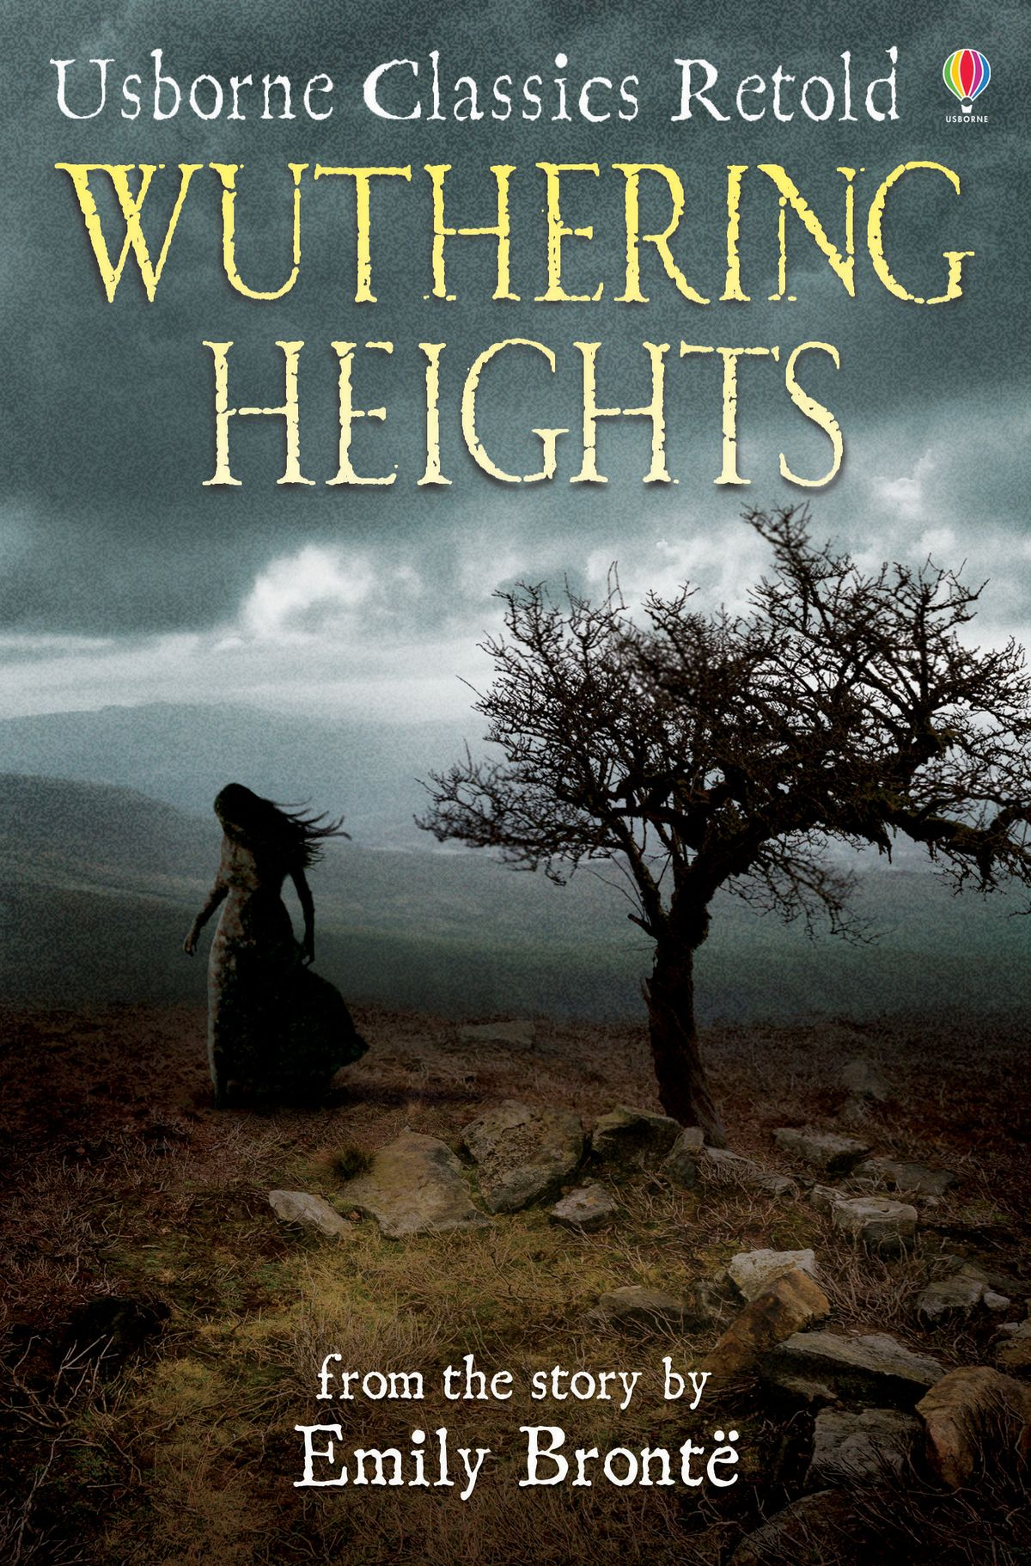 | Wuthering Heights by Emily Bronte  My favourite book I have ever read was Wuthering Heights by Emily Brontë. I read it a few years ago and I have gone back to it many times since. The story is about the love between Heathcliff and Cathy, how Cathy betrayed Heathcliff and what happens in his life after Cathy. The book starts in “modern day” but goes back in the past to Heathcliff’s childhood where we begin his life story. I would really recommend this book to others because it’s a very eventful story and very emotional!  Olivia Rose Haffey (Year 11)
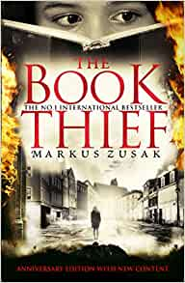 | The Book Thief by Marcus Zusak  I loved this book because it had a gripping plot and an amazing ending. This book is set in 1939 in Nazi Germany and the adventures and thefts of Liesel and her friend Rudy are narrated by Death. It is the perfect read for anyone who enjoys historical fiction novels!  Becky Irwin (Year 11)
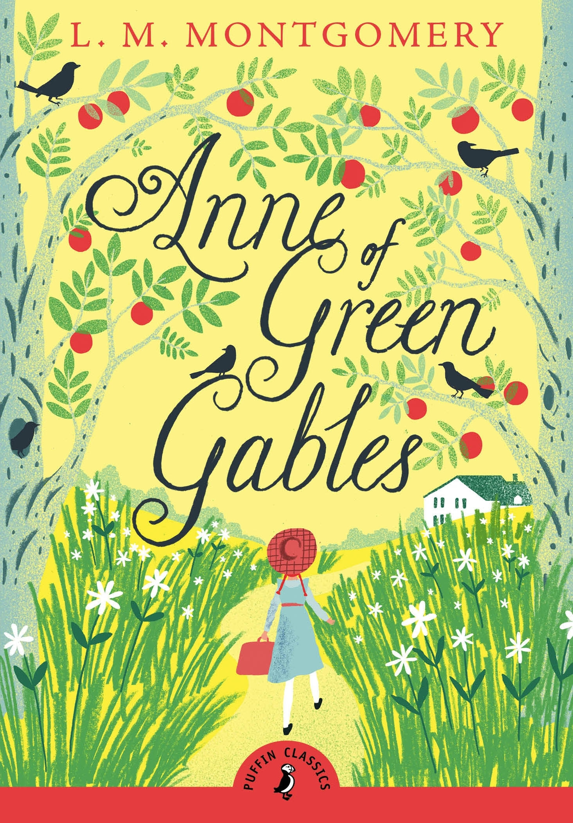 | Anne of Green Gables by L.M. Montgomery  I loved Anne of Green Gables because I was inspired by the main character, Anne. Her determination and ability to be herself when so many people bullied her and doubted her is something that I find extremely admirable.  Natasha Irwin (Year 13)
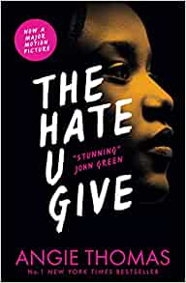 | The Hate You Give – Angie Thomas  I really loved this book. It is a novel about a teenage girl who grapples with racism, police brutality and activism after witnessing her black friend murdered by the police. I really enjoyed it as it relates to real life issues in the world and was very interesting and contains some very powerful messages.  Mia McAlpine (Year 13)
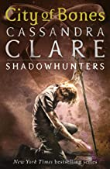 | City of Bones by Cassandra Clare  I loved this book because it was filled with action and it had quite an intriguing storyline. I also really liked the supernatural element and the humour of certain characters.  Chloe Sterritt (Year 13)
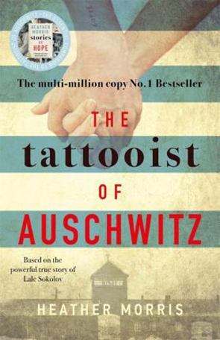 | Tattooist of Auschwitz by Heather Morris  The tattooist of Auschwitz is a true story set in 1942 following the life of Lale Sokolov, a Jewish man who arrived in Auschwitz-Birkenau. You follow young Lale who is given the job of marking his fellow victims’ arms with numbers to create what would become one of the most potent symbols of the Holocaust. While attending to his tattooing duties he meets a young girl. It was love at first sight for Lale and Gita. In this book you encounter and learn about the horrors of the extermination camps and the lengths Lale went to, to ensure himself and his love survived.  I enjoyed this book as it was moving and extremely eye opening to the extent of torture at the time of the Holocaust. It is a truly courageous, selfless and emotional novel.  Ella Goudy (Year 11)
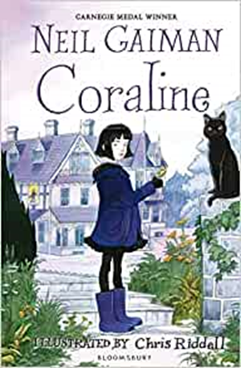 | Coraline by Neil Gaiman  The book, ‘Coraline’, by Neil Gaiman is a fantastical and mesmerising piece of dark literature. It greatly inspires me due to the captivating and unique character designs, alongside their equally intriguing personalities & backstories. Neil Gaiman uses the mundane and transforms it into something that can be terrifying, thus showing the world that even the most simple of objects and entities can instill fear into the reader.  Ben Keyes (Year 13)
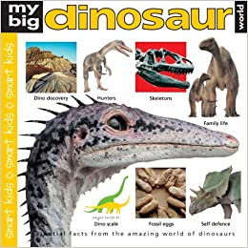 | My Big Dinosaur World by Simon Mugford  My Big Dinosaur World: an amazing book for anyone interested in Dinosaurs and I would recommend it because it has a lot of interesting facts and in depth detail on everything from the periods that dinosaurs lived to the actual dinosaurs.  Nathan Rafferty (Year 11)
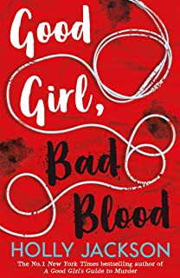 | Good Girl’s Guide to Murder/ Good Girl, Bad Blood by Holly Jackson  I loved reading these two books as they both had plot twists that shocked me. I would recommend these books to anyone who likes to read about mysteries. My favourite book is the second one (Good Girl, Bad Blood)) but I think you would have to read the first one to understand what’s going on!  Lucy Turkington (Year 11)
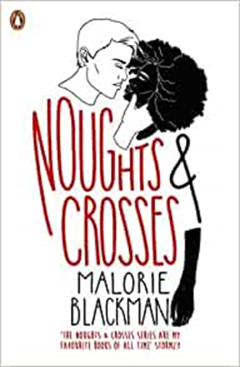 | Noughts and Crosses by Malorie Blackman  I loved Noughts and Crosses by Malorie Blackman because it was exciting but also made me cry. The crosses (ethnic minority) live like kings, ruling over the noughts (white people), who live like slaves. They are forbidden to see each other but they do not listen and become very good friends, with Callum soon realising he loves Sephy. Unfortunately, near the end of the book, Callum is killed. After Sephy falls pregnant, he is arrested for his actions as a member of the Liberation Malitia and accused of raping Sephy.  Katie Young (Year 11)
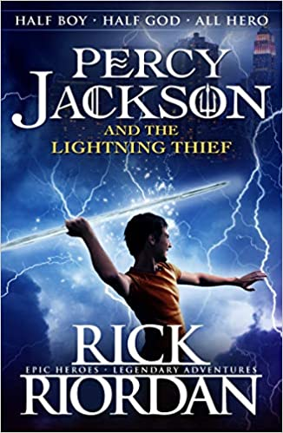 | Percy Jackson and the Lightning Thief by Rick Riordan  I loved this book because it appeals to my interests of Greek Mythology, action and adventure while keeping it relatable as teenagers struggle with their day to day lives.  John Speers (Year 11)
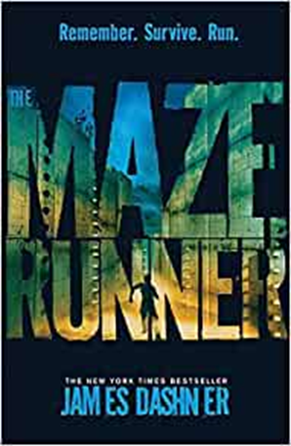 | The Maze Runner by James Dashner  I loved ‘The Maze Runner’ because the range of vocabulary and devices used in this book inspires my writing. I love how the writer writes in a way that makes you feel like you are actually there and you get to feel what the characters feel and you can relate to them. I highly recommend this book! I couldn’t put it down once I picked it up and started reading!  Mileli Gwaje (Year 11)
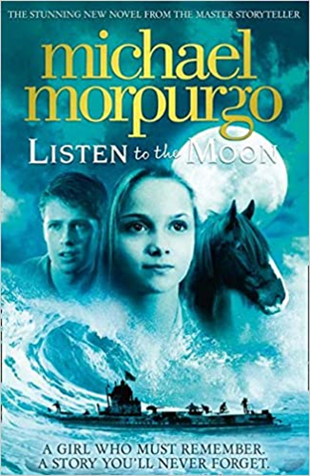 | Listen to the Moon by Michael Morpurgo  “On an uninhabited island in the Scillies, Alfie and his father find an injured girl - thirsty, hungry and with no memory of who she is or how she came to be there.  Is she a mermaid, a ghost? Or could she even be, as some islanders suggest, a German spy...”  I like this book because it is very mysterious, attention grabbing and makes you want to read more. It is quite moving and the characters are very interesting. It is full of ups and downs and a great ending.  Paige Laurison (Year 11)
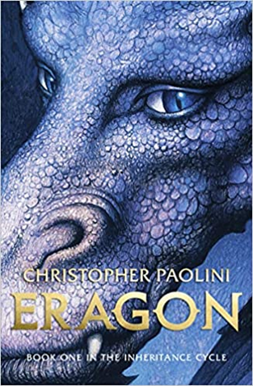 | Eragon by Christopher Paolini  I really recommend Eragon by Christopher Paolini because it has a very interesting storyline. I loved this book because of the Fantasy and Action Genres which includes dragons, magic and sword fighting.  Emily Balmer (Year 11)
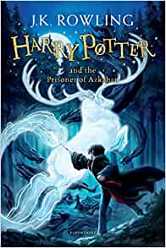 | Harry Potter Series by J.K. Rowling  The Harry Potter series inspired me to be creative and learn that creativity pays off. They also inspired me to never give up on an idea.  Ben Marshall (Year 11)
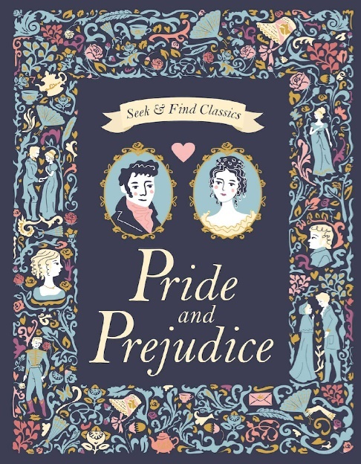 | Pride and Prejudice by Jane Austen  I very much enjoyed reading Pride and Prejudice by Jane Austen. It appealed to me because the story line was interesting to follow and the character development of the protagonist (Elizabeth Bennet) was executed very emotively. The romantic genre is also my personal favourite, therefore I enjoyed watching the events of the story unfold.  Lia Mileson (Year 13)  Pride and Prejudice by Jane Austen  I have loved reading Pride and Prejudice as it is set in a different time era and opens your eyes to different social customs and ideas. The different characters make the novel very entertaining and their personalities each add something new to the story. Even though the book was written a long time ago the language is fairly easy to understand and the plot keeps you engaged to find out how the storyline develops. I would highly recommend this book.  Hollie Martin (Year 11)
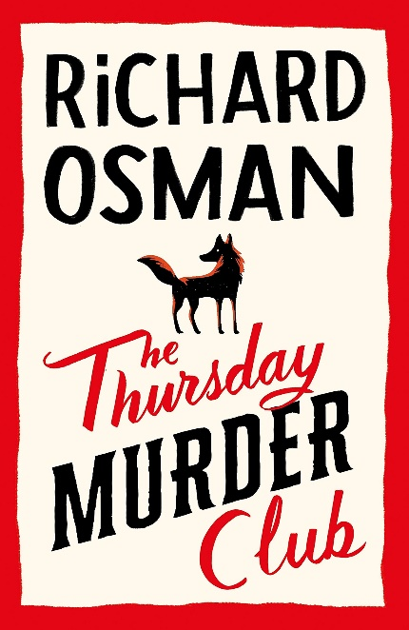 | The Thursday Murder Club by Richard Osman  I loved this book because it had elements of both comedy and mystery, it was a very captivating read because there were many intriguing plot twists. The plot consists of a murder which involves and takes place near a peaceful retirement village called Coopers Chase in England. It opens up long buried secrets which are unearthed by the Thursday Murder Club - no one is safe. The club consists of four very different retired individuals Elizabeth, Joyce, Ibrahim and Ron who connect over their shared curious detective tendencies. They usually solve closed cold cases every Thursday and this will be their first live case but when clues are discovered it spirals from one murder into many more. It is entertaining to guess who the murderer is along with the hilariously good British banter of the club and their associates (two coppers). You’ll never guess the ending so open it up and try to crack the case first!  Sarah Jackson (Year 11)

