PC6s
Information Pack
Who are we?
-We are Year 14 Portadown College Sports Science students and are running a mixed hockey tournament for our A2 Coursework.
-This information pack will provide you with any details about the event and how the day is planned.

What is a mixed hockey tournament?
-A mixed hockey tournament is a usual hockey tournament but with both male and female players on each team
-For our tournament, we will be playing 6 a-side with ‘roll-on roll-off’ substitutes
-We will be using a group-to-knockout stage format with four teams in each group and two groups altogether
-There will be a knockout stage for first and second place in both groups and a knockout stage for third and fourth place in both groups
-We are very excited about the mixed hockey tournament and hope you have an enjoyable and memorable day!

The timetable for the event is as follows:
9.30am | -Our staff arrive at Edenvilla  -Event is setup
10am | -Teams arrive at Edenvilla
10-10.10 am | -Check in for the teams  -Welcome to the teams and explanation of the event and the facilities
10.10am-10.25am | -Warmup for the teams

Group Stage
-Each match will be 10 minutes
-There will be a 3-minute break between each match to allow the next teams coming onto the pitch and the staff can be prepared
Time | Pitch 1/Group1 |  | Pitch 2/Group2
10.27 | Clounagh 1 | PC 2 | Killicomaine 2 | Tandragee 1
10.40 | Killicomaine 1 | Tandragee 2 | Clounagh 2 | PC 1
10.53 | Clounagh 1 | Tandragee 2 | PC 1 | Killicomaine 2
11.06 | PC 2 | Killicomaine 1 | Tandragee 1 | Clounagh 2
11.19 | Clounagh 1 | Killicomaine 1 | PC 1 | Tandragee 1
11.32 | Tandragee 2 | PC 2 | Killicomaine 2 | Clounagh 2

Knockout Stage
-Semi-finals are 10 minutes long
-3 minute break between semi final 1 and 2 to allow the next teams to arrive onto the pitch and staff to get organised
-Winners of Semi Final 1 will have a 20 minute break before the final.
-Winners of Semi Final 2 will have an 8 minute break before Final 2
-The final will be 12 minutes long
Time | Pitch 1 | Pitch 2
11.50- Semi Final 1 | Group 1 winner vs Group 2 Runner up | Group 2 winner vs Group 1 Runner up
12.02- Semi final 2 | Group 1 3rd place vs Group 2 4th place | Group 2 3rd place vs Group 1 4th place
12.20- Final | Final 1 | Final 2

12.32 | -Staff organise award ceremony
12.40pm | -A thank you from our team and staff  -Award ceremony  -Evaluation sheets handed out
1pm | -Teams begin to return back to their schools

*We will try to stick to this timetable as strictly as possible, but it may be subject to change*

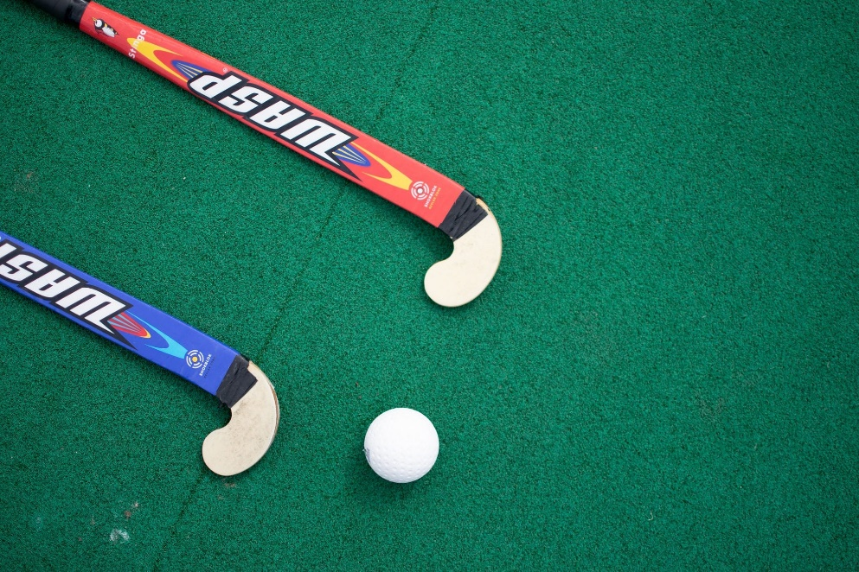

Rules of the Event
-The following rules have been given to us by Ulster Hockey.
-We have used the rules specific to our type of event, a mixed hockey 6 a-side tournament.
-Please remember that there should be 3 boys and 3 girls on the pitch for each team at all times.
RULE 1 – DURATION OF GAME
- Games will be played for 10 minutes straight. There will be no half time or changing of sides.
- 3 minutes will be scheduled between the end of one game and the start of the next. This differs after the group stage and between semi-finals and the final.
RULE 2 – SUBSTITUTIONS
- Substitutions are unlimited throughout the game.
RULE 3 – THE PITCH
- The Edenvilla Multi-Sports pitch will be split into two pitches, sideline to sideline. This will allow two matches to play simultaneously.
RULE 4– PLAYER EQUIPMENT & CLOTHING
- It is strongly recommended that shin-protectors and mouth guards are worn by all outfield players at all times during a game.
- No player shall wear any equipment that may be dangerous to themselves or other players.
- The use of appropriate footwear for the playing surface (trainers or turf shoes) are encouraged.
- Goalkeepers must wear a full padding, kickers, pads, abdominal protector, chest guard, protective gloves and a full helmet AT ALL TIMES
RULE 5 – UMPIRES
- There will be two umpires per pitch
- The umpires will be experienced hockey players within our school.
- The umpires are responsible for all decisions and penalties.
- The umpire’s decision is final.
RULE 6 – STARTING THE GAME / PASS BACK AWARD
- The first named team on the fixture schedule will provide the ball for the game.
- The first named team will be awarded pass back to start the game. A coin toss with captains is therefore not required.
- The game will start with a push or hit from the centre of the pitch. The ball can travel either backwards or forwards.
RULE 7 – STARTING AND RESTARTING THE GAME
- The game is started with a pass backwards or forwards taken from the centre of the centre line. It follows the umpires whistle indicating the start of the game or after a goal has been scored. The ball may be raised immediately using a push, flick or scoop but must not be raised intentionally using a hit.
- Each team must be positioned in their own half of the pitch and the opposing players must be a minimum of 5 metres from the ball until the centre is played.
- The ball can be played forwards, backwards or sideways.
- The taker can use a self-pass (i.e. pass the ball to themselves). The pass must involve two very distinct actions i.e. the taker must first tap it forwards, sideways or backwards and then play it a second time either to pass it or to dribble it.

RULE 8 – SCORING A GOAL
- A goal is scored when the ball has been struck by, or deflected off, an attacking player, or touches the stick or body of a defending player, while it (the ball) is in the shooting zone. It must cross completely over the goal-line between the goal-posts and under the cross-bar.
- Goals will not be awarded if the ball is struck outside the scoring zone and does not touch an attacker’s stick.
- A goal cannot be scored directly from a free hit / auto-pass. The ball must travel at least 3 metres by the attacking player before a shot can be made by the player taking the auto-pass. This will apply at long-corners and side-line balls within the scoring zone also.
- If a player takes an auto-pass and dribbles past one or two players, he/she is entitled to score, provided the ball has travelled at least 3 metres.
- All players except the striker must be 5 metres from the ball at free hits and corners and the ball must move at least 1 metre from all free hits, side line balls etc., when using an auto-pass.
RULE 9 – ACCIDENTS
If the game is temporarily suspended because of an accident or injury where no offence occurred it shall be re-started with a bully close to the spot where the accident occurred.
- Players must stand square of each other and prior to playing the ball and following the umpires whistle, they shall tap the ground with their stick once and tap each other’s stick above the ball once.
- All non-involved players must be a minimum of 5 metres from the ball.
- Players who are cut or bleeding will be required to leave the pitch immediately and will be looked at by our first aiders
RULE 10 – INCIDENTS
- An incident differs from an accident as this is something that may have happened intentionally. Bullying, Physical or Mental abuse are all examples of incidents.
- We believe that all participants will be respectful and kind to one another. However, if any negative incidents occur, certain players may be asked to leave the pitch and a substitution will be allowed for another player to come on instead.
RULE 11 – FAIR PLAY
- Rough or dangerous play shall not be allowed, nor any behaviour which in the opinion of the umpire, amounts to misconduct.
- Players must not intentionally use any part of their body to play the ball
- Players must not play any high ball with the stick held at above shoulder height unless they are attempting to prevent a goal from being scored (i.e. to defend a shot on goal). The shot must be on target.
- Players must not use the rounded side of the stick when playing the ball and when striking the ball. The stick must in no way cause danger, nor lead to dangerous play, or be intimidating to any opponent.
- Players must not play in any way that is dangerous.
- Players must not kick the ball.
- Players must not obstruct by running between an opponent and the ball, thereby unfairly preventing the opponent from playing the ball. Neither must they use any part of their body or stick to obstruct a player.
- Players must not hold, charge, kick, shove, intentionally trip, or strike any player or umpire.
- Coaches and spectators must remain respectful at all times. Challenges to decisions should be directed courteously and if possible through the team captain.
Our Staff
-At PC6s, there will be the following roles:
- Technical Director
- Assistant Technical Director
- Score Recorders
- Announcer
- Health + Safety Officers
- First Aiders
- Umpires-
-Jamie Talbot
-Jack Turkington
-Matthew Smyton
-John McQuitty
-Annie Gordon
-Jessica Allen
-Hannah Armstrong
-Megan Kernaghan
- Car Park Attendees
- Pavilion Assistants
-Our staff will be available throughout the entire day and will be willing to answer any questions.
Participant Information
- Please arrive at Edenvilla at 10am in your school PE kits with your hockey equipment.
- There will be a period of time between 10-10.25am for teams to warmup and ask any questions before the first matches kick off at 10.30am.

What you will need:
- Your school PE kit
- Suitable hockey shoes/trainers for the Edenvilla pitch
- Hockey stick
- Mouth guard
- Shin guards
- An extra layer (hoodie or jacket etc)
- Plenty of water (please do not share water due to Covid-19)
- Optional- Snacks (nut free)
-We would ask that participants do not bring any valuables to the event
-If any participants or parents have any questions about the event before the day, please contact Portadown College as we are willing to answer any questions
-If participants have any questions during the event, please look for staff in aluminous yellow jackets as we will be willing to answer any questions

Facilities
-The Edenvilla multi-sport pitch is a fantastic venue for the mixed hockey tournament
-There will be signs for each of the facilities being used during the event, these include:
- Male and female toilets
- Pavilion- This may be used for teams who are not playing a game
- Dugouts
- Walkway surrounding the pitch to watch matches
- There will be designated areas designed for each of the four schools to stick to as much as possible, especially when a team isn’t playing a match
- Changing rooms are provided if needed

Transport and Registration
-Buses will arrive in the Edenvilla car park
-Schools and their two teams will be met by our staff, in Hi-Vis jackets, where they will then be checked into the event and registered
-It is very important that each player and spectator is registered at arrival and stays with their team/school
Health + Safety
-To ensure the health and safety of players, we ask each participant to read through the rules of the game and abide by these rules
-We ask that players take into consideration that other players may be younger/smaller than them
-Please ensure that for each game, players are wearing appropriate footwear, mouth guards and shin guards
-The weather will be unlikely to affect the tournament but, if necessary, we will review if bad weather could affect the health and safety of players
-We ask that anyone attending the event is careful on the steps at Edenvilla
-In the unlikely event of an emergency or accident, we will have first aiders attending the event and first aid equipment
Covid-19 Guidelines
-There is a possibility of a one-way system in place at the event. This will be confirmed on the day of the event and participants and spectators will be made aware of this
-Each school and their two teams will have a designated area for when they are not playing games.
-We ask that players and anyone attending the event uses hand sanitiser when necessary and brings a mask
-If any player or person attending the event feels unwell or has any Covid-19 symptoms, we ask the not to attend the event due to Covid-19 guidelines
-Each player will be registered at the start of the event for Covid-19 traceability and health and safety
Photography
-We will have a photographer attending the event to take pictures
-These pictures may be shared on the Portadown College social media pages and website
-If any participant does not want pictures of them to be shared, please contact Portadown College to make us aware of this
Award Ceremony
-After the event, there will be an award ceremony in which trophies will be awarded to the winners of the two knockout stages

s
AREA 1
AREA 2
AREA 4
AREA 3
STEPS

PATH
ENTRANCE/PATH
PAVILION
FENCE/TREE LINE
CAR PARK
PITCH 2
PITCH 1

ROAD

Parent/guardian information
-We have permission to allow any parent/guardian or family member to attend the event to spectate
-If parents/guardians have any questions or queries about the event, feel free to contact Portadown College
-We would ask parents/guardians and family members to abide by the Covid-19 guidelines and also register into the event with our staff

Contact
-If there are any questions about the event, please use the following methods to get into contact with Portadown College:
- Telephone- 028 3833 2439
- Email- info@pc.portadown.ni.sch.uk

*If players need assistance with any hockey equipment or other resources, please contact us and we will try our best to help*

