WBD 2021 Staff Book Reviews
Mrs Murphy
Dear Reader by Cathy Rentzenbrink
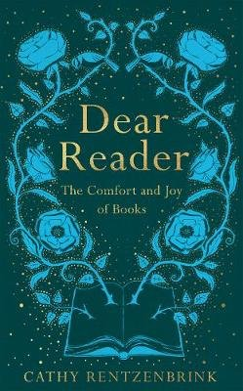
When the bite of real life is too brutal, I retreat into made-up worlds and tread well-worn paths.......It is as though in re-encountering my most-loved fictional characters, I can also reconnect with my previous selves and come out feeling less fragmented. Reading built me and always has the power to put me back together again.”
These wonderful words written by Cathy Rentzenbrink in ‘Dear Reader’ remind me of how much I have enjoyed books over the years.
Cathy’s book takes the reader through her reading journey, from Narnia, through Dickens to Agatha Christie and everything else besides. I couldn’t help reading the early chapters without feeling nostalgic for my favourite childhood books, and was intrigued at how similar my early reading was to Cathy’s.
I loved the magic of all the Narnia books, full of fantastical worlds with speaking fawns and one of my lasting memories is of Reepicheep’s departure in The Voyage of the Dawn Treader. I have a keen sense of justice and loved books where good conquered evil, a pattern that is repeated throughout good reads whether it’s Narnia, The Lord of the Rings Trilogy or Harry Potter. This characterised my teenage reading where I worked my way through Dickens, longing for justice and happy endings for impoverished and abused characters. Sydney Carton’s words in A Tale of Two Cities epitomised this for me: “It is a far, far better thing that I do, than I have ever done; it is a far, far better rest that I go to than I have ever known.”
Like Cathy Rentzenbrink, books have continued to be my companion. They have in her words “brightened my days, expanded my horizons, and kept me company through my darkest hours”.
For those of you seeking inspiration for your next read, check out Cathy’s fond recollections of her favourite books in ‘Dear Reader’- coupled with some witty memories of working as a bookseller in Harrods.

Mr Richardson
The High Girders by John Prebble
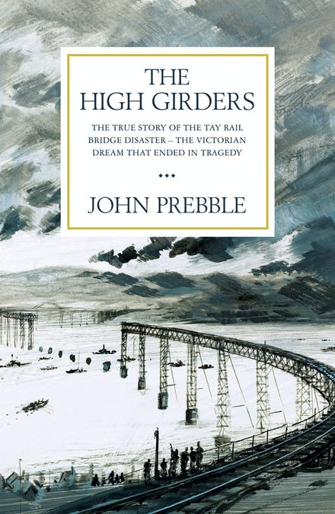
In my early teens, I headed off on a tour around Scotland by rail with my older brother and a friend. While travelling up the east coast we crossed the Firth of Tay on the Tay Bridge, an impressive piece of Victorian engineering nearly three miles long. Half way across the bridge, I noticed a number of large concrete blocks protruding from the river and was informed these were the remains of the previous bridge which had collapsed in a storm, over a hundred years ago, killing all passengers on a train making its way across the bridge. This stoked an interest into what happened and in the days before Google, a book was the answer! I was given a copy of this book and it provided an insight into the challenges of constructing such a feat of engineering in the 1870s, what happened on the fateful night of 28 December 1879 and the aftermath of the disaster.
This was my first book on railway engineering and it sparked an interest which has continued to this day!

Mrs Willis
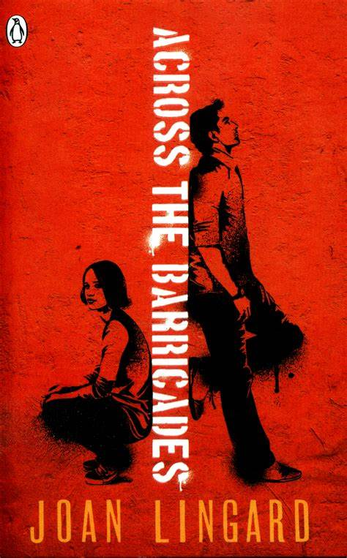
Across the Barricades by Joan Lingard
Remember fondly “The Twelfth Day of July” and “Across the Barricades” by Joan Lingard (did have to just google the author) ...not sure I have adequate literacy skills to explain why they had an influence…but I never forgot Sadie and Kevin…much easier to read than Romeo and Juliet and a happier ending! Maybe that’s why I remember!

Mr Quaile
A Gentleman in Moscow by Amor Towles.
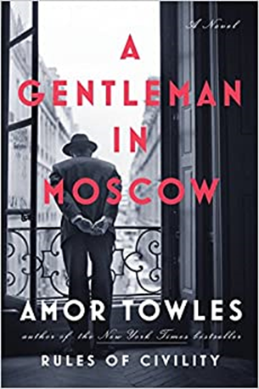
This is set in 1922 post-Bolshevik Revolution Russia and the main character is a former aristocrat named Count Alexander Rostov. He is sentenced to confinement in a small room in the servants' quarters, (for the crime of being an unreformed aristocrat), of a central Moscow hotel and the book charts his decreasing status at the same time as he embarks on a journey of self-reliance and self-discovery, all the while observing Russia's tumultuous upheaval. Extremely apt for our current situation!
The best quote from the book is: "...adversity presents itself in many forms; and that if a man does not master his circumstances then he is bound to be mastered by them.".

Mrs Hurst
Little Women by Louisa May Alcott
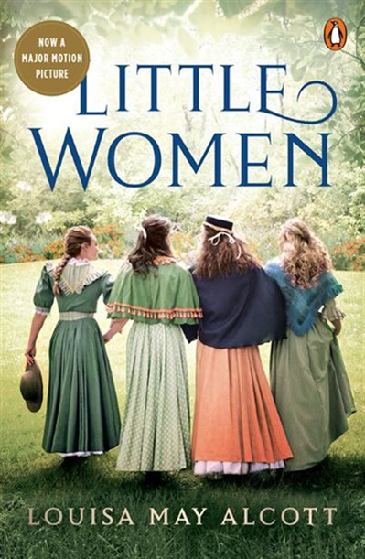
I was a youngish teenager when I read Little Women by Louisa May Alcott and can still remember that my favourite character was Jo. The book was set in the USA at the end of the 19th century and is a coming of age story about a family of four girls during the American Civil War. Jo was about my age, was headstrong, had a temper, and was a bit of a tomboy – a bit like myself at the time! Ever since, I have loved books with strong female characters from all walks of life.
Some more examples of great books with strong female characters I have loved in recent years include: Elena and Lila from “The Neapolitan Novels” by Elena Ferrante; Lisbeth from “The Girl with the Dragon Tattoo” by Stieg Larsson; Mariam and Laila from “A Thousand Splendid Suns” by Khaled Hosseini; Marie-Laure from “All the Light we Cannot See” by Anthony Doerr; and my current read, Kya from “Where the Crawdads Sing” by Delia Owens.
I went to the cinema just before lockdown to see the latest “Little Women” film and loved that Saoirse Ronan, one of my favourite actresses, played the role of Jo. I had forgotten how sad the book was but enjoyed watching Saoirse bring Jo’s strong female character role to life.

Mrs Montgomery
The Mill on the Floss by George Eliot
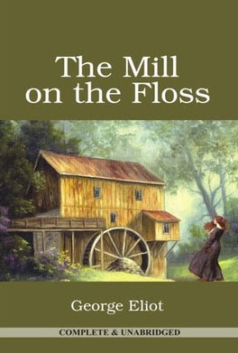
As a teenager (a long, long time ago!) I loved The Mill on the Floss by George Eliot. The author is female and the fact that she gave herself a male pen-name is reflective of how men were regarded as intellectually superior to women.
I loved the central character Maggie and related to her rural background and the sense she was trying to make of life, spiritually, emotionally and intellectually. I love a book in which you can immerse yourself so intensely that you actually miss the characters and your engagement with them when you stop reading.
I am currently reading Where the Crawdads Sing by Delia Owens, which again has a strong central female character and a strong sense of place.

Miss Gibb
My Brilliant Friend by Elena Ferrante
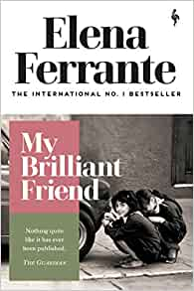
The book I enjoyed most during lockdown is My Brilliant Friend by the Italian writher Elena Ferrante (translation by Ann Goldstein). A beautifully observed 'coming of age' novel, My Brilliant Friend tells the story of Elena and Lila, two friends growing up in a poor but vibrant neighbourhood in Naples in the 1950s. The novel evocatively captures the cultural atmosphere and social environment of post-World War Two Italy, journeying with the girls as they negotiate family relationships, friendships and their transition to young adulthood. The aspects of this novel that I love most are the vibrant immediacy of Ferrante's voice and the richly descriptive landscape of southern Italy. My Brilliant Friend is a rewarding read for anyone interested in human relationships, cultural values and social mores.

Mr Lowry
The Tattooist of Auschwitz by Heather Morris
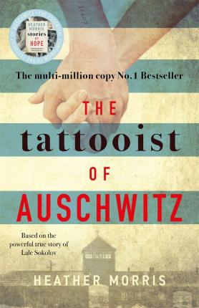
As a History teacher, I have always been drawn to books that give the reader an insight into events from the past. A Tale of Two Cities gives us a peak into the world at a time of great change in the late 18th Century, whilst To Kill a Mockingbird allowed the reader to witness the deep rooted racial prejudices that existed in the southern states of the USA in the early 20th century through the eyes of young children.
More recently, I found that The Tattooist of Auschwitz, by Heather Morris, gave me a vivid insight into the horrific lives that were led by those who were transported to concentration and death camps by the Nazis during World War Two. Throughout the novel the main character, Lale Sokolov, witnesses brutal acts during his time in Auschwitz, yet he also witnesses acts of bravery and compassion. Indeed, Lale’s own actions ensure that other prisoners stay alive when they would otherwise have been killed by the Nazis or the harsh conditions within the camp.
Overall, this book represents a fine example of hope in the face of adversity.

Mrs Press
The Time Traveller’s Wife by Audrey Niffenegger
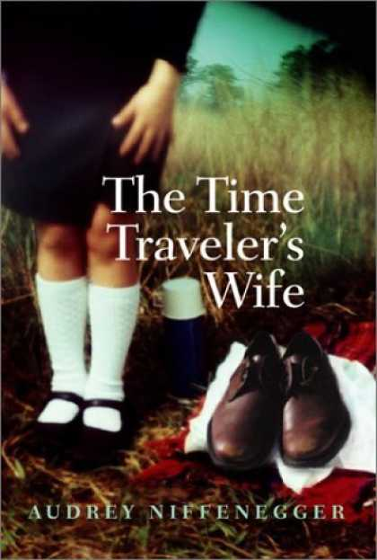
My favourite book is The Time Traveler's Wife: the debut novel by the American author Audrey Niffenegger. It is a love story about a man called Henry, who has a genetic disorder that makes him time travel unpredictably - and his wife, Clare. It is a dual narrative - so we hear both sides of their story. It’s a really dynamic mix of science fiction and romance. But it’s also about our failure to really communicate with each other, which creates dangerous distance. I found this book so moving that, when I finished it, I cried. For me, that is the sign of a good book: it involves the whole of our emotions, takes us completely out of ourselves - and we miss it when it’s done.

Mrs Symington
The Twelfth Day of July by Joan Lingard
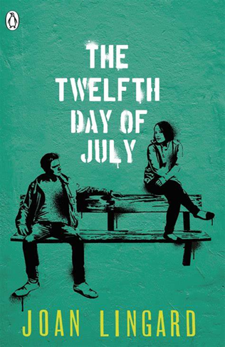
The book that I read and still remember vividly was The Twelfth Day of July, by Joan Lingard. A book about the Troubles and a relationship that was to form between Sadie and Kevin, teenagers from across the religious divide. The book was innocent but insightful and finished with Sadie and Kevin climbing the Cavehill on the Twelfth of July to look down on the whole of the city that lay before them. I remember reading this when I was 13 and as a child of the 1970s all aspects of the book resonated with me.
Thankfully we have moved forwards since then and in January this year I climbed the Cavehill for the first time to look down on a very different city form the one that Sadie and Kevin did.

