Top Tips for Remote Learning
Follow the tips below to help you get the most out of the current period of remote learning.
Rise and Shine!  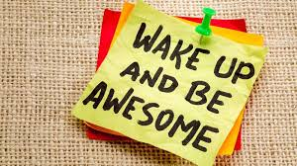  Get up early, have a good breakfast and be ready to learn! | Be Prepared!  Make sure your device is fully charged, have headphones if you need them and make sure your camera is working. | Put other devices away  Where possible, put your phone away. Try not to work near televisions or games consoles.
Check!  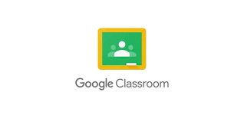  Using your timetable, visit each of your Google Classrooms for that day at the time you would in school. | Presentation  Where possible, work in a quiet room with no distractions in the background. Make sure you dress appropriately. | Communicate  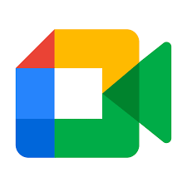  Stay focused during the day and in Google Meets. Make sure you are muted. Raise your hand to ask questions.  Check the Netiquette information for details.
Inform  Let your teacher know in advance if you are not going be able to attend a live class or if you have difficulty submitting work. | Take a break!  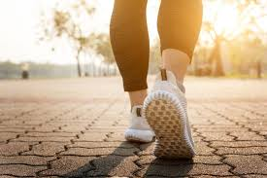  Spending a long time in front of a screen isn’t healthy. Remember to get some fresh air and enjoy other activates. | Look after yourself!  You may miss the daily routines of school. If you feel frustrated or sad, talk to a parent or teacher. Keep in touch with friends online.

Remember! You should ensure their C2k log in details are working. Should you have any difficulty accessing the C2k services, you should email Mr Robinson crobinson946@c2ken.net using an alternative e-mail address. He will change your password and reply to that address between 9:00am and 4:00pm Monday to Friday.

