Portadown College Primary Schools’ Cross Country Competition
Information Pack for Primary Schools

We would like to welcome you to Portadown College, for our Cross Country Event.
Please arrive at PC for 10am on Friday 13th of December
Timetable for the morning
10:00am | Arrival and Registration
10:45am | Fun Run
11:05am | Girls Race
11:20am | Boys Race
11:50am | Presentation of Prizes and Pick up

. Drop off and Bus Parking
- Arrive via Killycomaine Rd, using the bus layby outside the gates of the school.
- There will be no facility for bus parking inside the school grounds.
- Pick up after the event will be from the bus layby
You will be met by a steward in a high visibility jacket and walked you down safely to the registration area. Changing facilities are available in the Sports’ hall and will be pre allocated.
Parking information for parents and spectators
Parents and spectators are asked to park on the right hand side of the main school carpark. This will be sign posted.
Check list for participants:
- Water bottles
- Warm clothes
- Change of clothes
- Bag for belongings
- Change of footwear
- Snacks (nut free)
- Spare socks
- Plastic bag for dirty clothes
- Please do not bring valuables

All competitors will be chip timed, numbers will be distributed at registration.

Changing Facilities
- Runners should come in kit and ready to run
- All changing and toilet facilities are located in the Sports’ Hall
- Boys changing will be in Changing Rooms 1 and 2 and the Girls changing will be in Changing rooms 3 and 4.
- There will be a staff briefing on arrival at registration. Registration will at the side of the Pavilion.
- Toilets will be signposted and shown to the children. Bins will be provided.
- Please do not bring valuables to the Cross Country

Rules
In the Boys and Girls team races the top four times will count, with the team having the lowest cumulative score winning.
There will also be a prize for the overall winning school. This will be calculated using the times of the top 4 boys and the top 4 girls from that school, with the school having the lowest cumulative score winning.

Health and safety
Please make sure that the children are wearing appropriate footwear. We suggest spikes, trail shoes, football boots or trainers. Also ensure they wear appropriate clothing, including base layers.
The course may change if bad weather occurs, for the health and safety of the children.

Race Timetable
All children must meet in the race registration area 10 minutes before their race, this is to ensure that we have all the correct children in the correct races. Please see below for registration and race times.

Race | Registration time | Race Time
Fun Run | 10:35am | 10:45am
Boys Race | 10:55am | 11:05am
Girls Race | 11:10am | 11:20am

The top three in boys and girls in the competitive races will get trophy.
All participants will get a medal for their participation in this event.
Presentation of prizes: 11:50am (this may be subject to change on the day)

First Aid
First aid will be available, but please ensure to bring any medication needed to this event. Things like Epipens, inhalers etc.
Map
A map of the course and other key information is provided. All races will be 2 laps of the course.
The course will be 1600m approx
Photo and results service will be available on Portadown College website, there will be a separate page for this event on the home page www.portadowncollege.com
You can also follow the event for information and other updates on the PE Department Twitter account @pc_sport.
We have planned a contingency date for Monday the 16th of December.
The details below are on information about parking for buses and parents and a map of the course.

Details of School Grounds
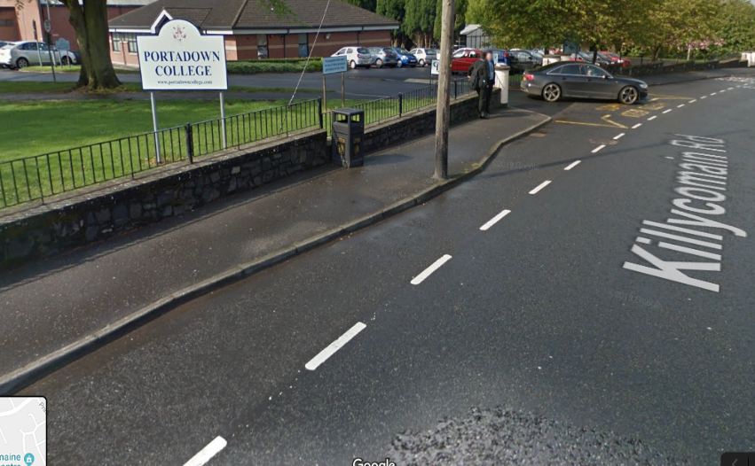
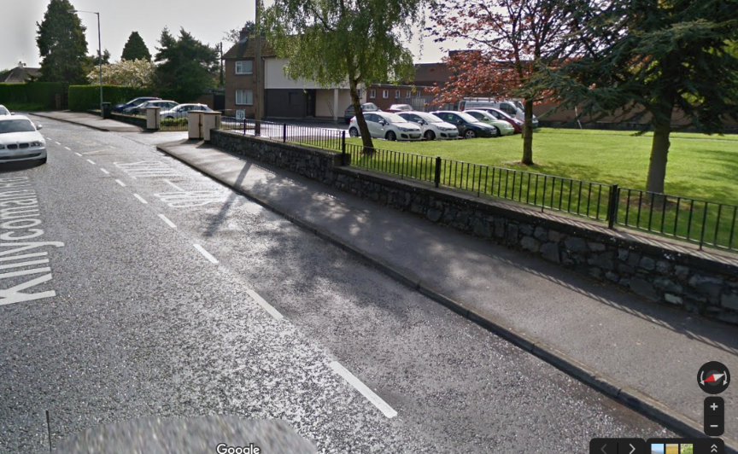
The buses are advised to go around the roundabout in the middle of Killycomain Road (leads to Princess Way) and then drive back towards the school this will ensure that all buses are dropping off on the same side and helps to ensure safety of pupils as they all are getting off to the footpath and will not have to cross the road. We will have a steward for each school bus to escort the teachers and pupils down to the pavilion for briefing.
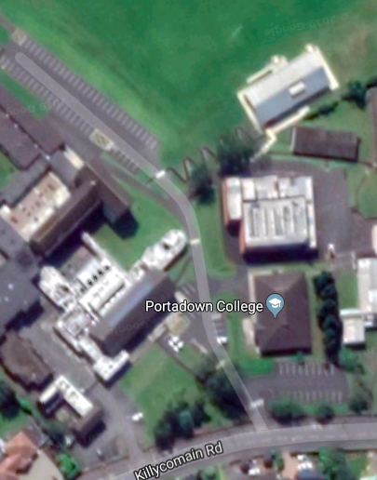
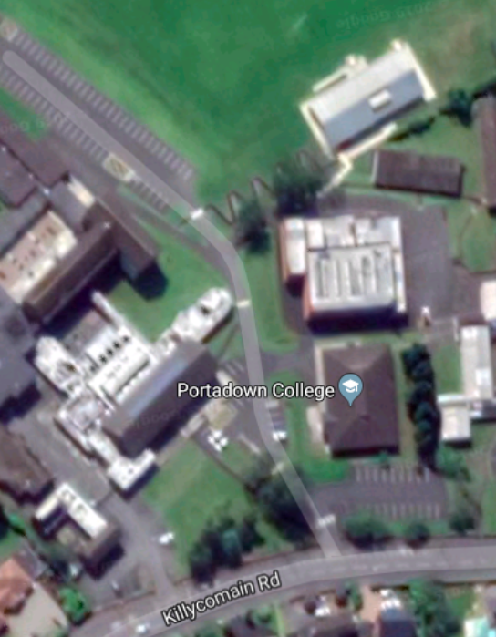

The pictures above show the layout of Portadown College, the venue of the Cross-Country event. The schools will be dropped off at the drop off point on the Killycomain Road and then will be escorted by a designated steward down through the school grounds on the safest route (yellow line). They will be escorted to the Pavilion Fitness Suite (outline blue) which will be the main centre to the event with the information desk being located here. The Pavilion (Blue line) and the Sports Hall (Red line) provide shelter and facilities for changing with changing in the Sports Hall. These facilities provide toilets for males and females. Defibrillator is located in the sports hall and first aid kits available in the Sports hall and Pavilion (below).

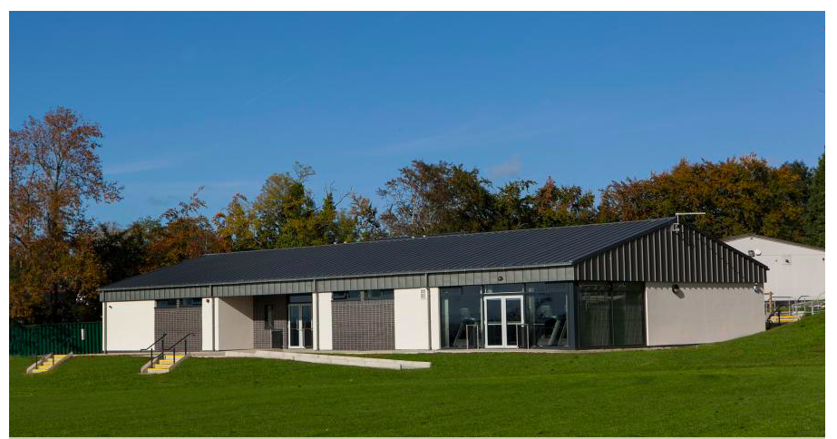
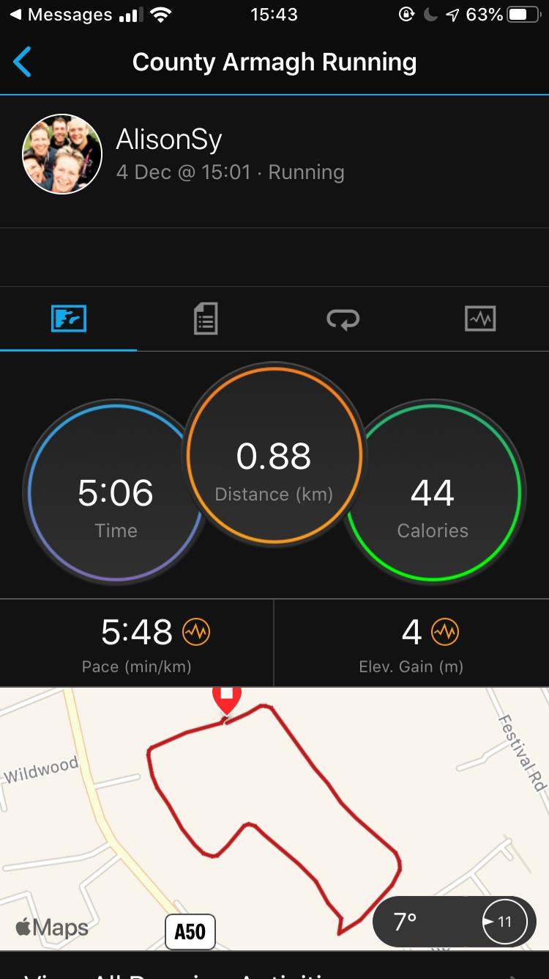
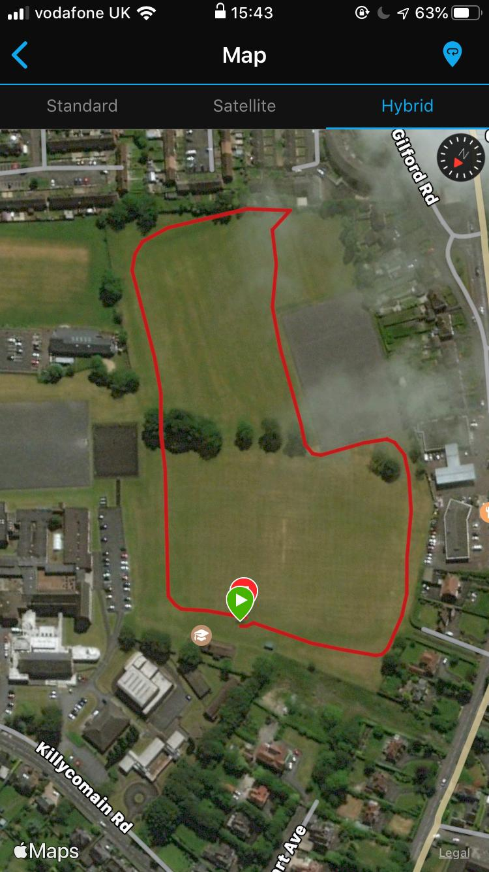
The photos above show the potential course and the distance of one lap of that course. The course started and finished infront of the Pavilion as this is where we plan to have the main information desk to allow the event to be managed and time kept easily. This route and course was chosen as the participants are of the age where supervision at all times is vital and this course allows all of the route to be seen from the pavilion. Along the route stewards will be strategically placed with at least two at each station, this ensures that if there has been an accident/incident they will be able to report to the information desk through communication and take action to whatever the incident is.

Course and Registration area
The photos above show the potential course and the distance of one lap of that course. The course starts and finishes in front of the Pavilion as this is where we plan to have the main information desk to allow the event to be managed and time kept easily. This route and course was chosen as the participants are of the age where supervision at all times is vital and this course allows all of the route to be seen from the pavilion. Along the route stewards will be strategically placed with at least two at each station, this ensures that if there has been an accident/incident they will be able to report to the information desk through communication and take action to whatever the incident is.

Parent and Spectator Parking
We have planned to allow the parents to watch by providing parking for them. (blue circle). This will only have a limited number of parking spaces available as it is a staff carpark. To ensure safety, parents will be asked to arrive at a time closer to the start of the race to ensure the safe transport of the children down to the meeting/registration point which is circled in purple. If there are no car parking spaces left the parents will be asked to find safe alternative parking within the local area which is not obstructing the local community. To ensure safety of the children, areas of the school will be cordoned off and will be an area of no cars to ensure safety of the children is paramount.

