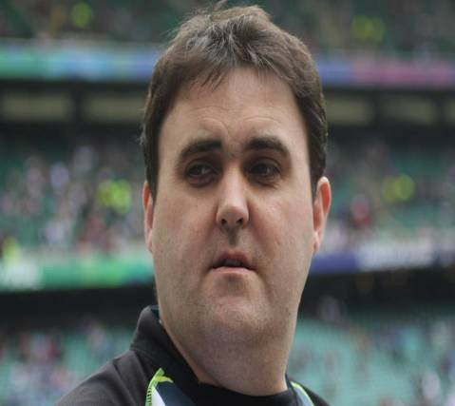
Name: Ian (Spud) Kennedy
Past Pupil of PC 1995-1999
Job: Qualified Pharmacist and training to be a Doctor
1. Why did you choose to study GCSE/A-Level biology at Portadown College?
At Killicomaine I felt that when deciding what to do for GCSE that triple award science at the time would have been the best option for me as the scientific side of my brain at least functioned compared to the arts side.
After finishing GCSE trial examinations and having to decide on A-level choices, choosing Biology again was easy as it and Chemistry were the two subjects that I actually wanted to do. I also felt that they were two subjects that could open the door of various career paths especially in the medical profession.

2. What skills/ qualities/knowledge did you gain from your studies?

Biology at the college gave me a solid foundation for university and also an appreciation of how the body actually works at a cellular level as well as a complex complete unit.
Looking back at A-level and GCSE at the time I didn't probably appreciate the importance of having an understanding of such things as the heart cycle, respiration, the breakdown of carbohydrates etc in detail. When it came to Queens and coming across these and numerous other subjects in greater depth I was thankful that I could still visualize some of those initial experiments and explanations from school.

3. After leaving school what did you study in third level education? (if applicable)

After leaving school I studied Pharmacy at Queens University. I was always interested in medical breakthroughs in the treatment of various illnesses/diseases and how medicines helped patient recovery. I worked as a pharmacist in both a community setting and then for four years in Craigavon Area Hospital.

Working in the hospital as part of a medical team gave me the appetite to take my studies further. I am currently in the final year of medicine at Queens University.

4. What career path do you hope to follow in the next few years?
That’s an interesting question!
My career path is not one that your careers teacher would recommend! I qualified as a pharmacist and as stated previously I worked for a few years in a community and hospital based environment. Being in the hospital environment showed me that I would rather have a more hands on approach in the diagnosis and treatment of patients rather than just checking patients were being prescribed the right drugs and in the right doses or what other treatments a patient could have.
I decided to go back to Queens University and study medicine. Next year I will hopefully be a practicing Doctor. Having my Pharmacy degree definitely has given me an advantage in the diagnosis and treatment of patients but I am definitely enjoying have a much more hands-on approach. I have also been keeping my pharmacy work on at weekends as a locum pharmacist which has helped pay for my university fees and accommodation in Belfast!
My medicine degree has consisted of many placements in hospitals around N. Ireland but, as I am a keen traveller, I have also had the opportunity to complete some placements in Canada and America where I would definitely consider working in the future.

