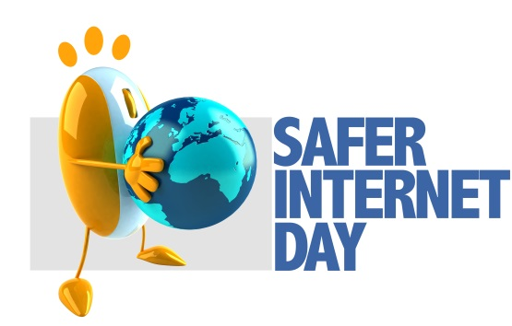
Scam: a dishonest scheme; fraud
Fraud is deliberate deception to secure unfair or unlawful gain or to deprive a victim of a legal right.
Scam is a very serious and dangerous topic for young people in this generation. There have been warnings about ticket scammers targeting next year's hugely-anticipated tour by Adele after all tickets sold out in a matter of hours.
According to Action Fraud, more than £1.2 million was lost to ticket fraud in the last six months, with more than 3,000 cases reported between May and October.
On average, victims lost a whopping £444 per transaction.
Major shows next year including the Stone Roses and Coldplay are also likely to be targeted by fraudsters. Portadown College student Leah Badger was scammed online. Leah was so excited to see her favourite gospel group, she bought her tickets on EBay for around £100. The vendor sent out fake tickets, hence she was scammed. Fortunately, Leah acted fast and was able to get her money back.
More than 1000 people from NI are on a so-called “suckers list” after being targeted by international fraudsters, statistics are very high and it’s becoming increasingly dangerous.

Leah badger: victim of ticket scamming
Stay safe online:
Don’t share your bank details
Get parents to check before spending money
Only buy from someone who has 100% rating

