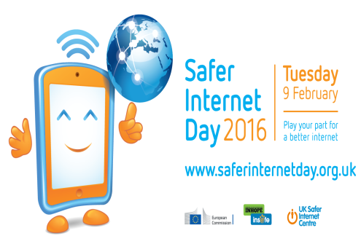
Behind the controller
The internet isn’t always what it seems to be. Most assume that they are untouchable behind a computer screen or controller. They feel as though they can do what they want, it is impossible to find them and they could lead a double life in another reality.
I would like to say that this untrue.
Unfortunately the internet is an ocean of hackers, bullies, scammers and predators and that ocean is growing deeper and deeper every day. It is very difficult to pin-point a murderer, a predator or a hacker when all you have is fake information and no form of facial identification.
For Breck Bednar (14) this discovery would be fatal. Breck was a typical teenager, full of ideas and questions about the world around him. Unfortunately his life was cut short by the hands of Lewis Daynes, having met through online console gaming months before his untimely death.
After months of talking and gaming together, Breck was lured into a social group of Lewis’ friends with a promise of a prosperous career in computing and gaming. Lewis arranged for the two to meet in person at his home in Essex, but his trap was set.
Prior to the meeting Lewis had messaged Breck with specific instructions to tell his father that he was staying over at a friend’s house. Breck would not be returning home.
Following the murder, the police discovered the unsavoury motive behind the murder: Breck had been groomed.
Though Breck’s mother, Lorin LaFave, had been curious of her son’s new found friendship online she could only investigate so much with the limited information she had. Nobody could have imagined that this horrifying ordeal could’ve happened in such a short amount of time, but it did.
Many don’t understand the levels of danger they face once they log online. Cyberspace is a dangerous place and it shouldn’t be taken lightly.
Stay safe online…..
- Enable safe search and parental settings if you are below 15 years old
- Do not share personal information, e.g. bank details, address, phone number
- Only accept requests from people you know in real life
- Remember, people might not be who they say they are

Stay safe online…..
- Enable safe search and parental settings if you are below 15 years old
- Do not share personal information, e.g. bank details, address, phone number
- Only accept requests from people you know in real life
- Remember, people might not be who they say they are

