SELB Area Proposal Plans for Portadown College
BREAKING NEWS! 13/02/14
Click here to go to page on SELB website containing the outcome of the Dickson Plan Consultation Questionnaire and select "Craigavon Consultation Report"
Click here for BBC News report "Dickson Plan: Board scraps plans to merge schools"
SELB Questionnaire 6th December, 2013
Click on the three documents below for more information about the SELB Questionnaire:
Suggested answers for SELB Questionnaire
Completed questionnaire example
FAQs for SELB Questionnaire
Suggested response to Q7 of Questionnaire
Click here for contact details for Concerned Parents' Groups, SELB Heads and members of NI Assembly Education Committee
Read the front page article from The Times Oct 15, 2013 here
"School shake-up: technical colleges for teenagers"
Click on here for "Myths about the SELB Proposals" (2nd October, 2013)
Click on here for the "Save the Dickson Plan Factsheet"
DUP Leader and First Minister Rt. Hon. Peter Robinson MLA, pledges support for the Dickson Plan
“My DUP colleagues in Craigavon and Tandragee have conducted an excellent campaign for the protection of the Dickson Plan. I was delighted to meet with representatives of the Colleges in Lurgan and Portadown earlier in June. Indeed, I gave an undertaking to do all in my power to halt those who want to decimate this system. Any decision to go against the community wishes would clearly be controversial therefore would be open to challenge at the Executive.
The Dickson Plan form of education has operated in this area for over forty years. Its unique two-tier system is cherished by those who have passed through the schools and has widespread community support. The DUP is united in its support of this localised system and will continue to campaign against those who attempt to decimate and destroy the Dickson Plan.”
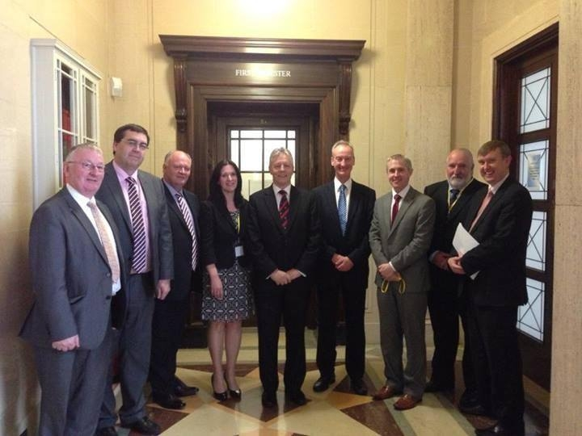
Please click on the links below to read the story so far.
Portadown College and Lurgan College Joint Response to SELB Proposals for Post Primary Provision in the Craigavon Area dated 16th April, 2013
Portadown College's Final Response to SELB Proposals 3rd May, 2013
PARENTS - WE NEED YOUR HELP!
Please also convey your views to the SELB regarding the future of the Dickson Plan and Portadown College before Monday 24th June. A copy of a suggested letter can be downloaded below:
Letter sent home to parents dated 4th June, 2013
Suggested letter to Mr Murphy, Chief Executive Officer of the SELB
PUTTING PUPILS FIRST?
SELB letter sent to Portadown College 11/06/2013 about requested improvements to our school.

