Links to be included in Pupil Zone:
My School https://www.c2kschools.net/standard/Index.aspx

CCEA http://www.ccea.org.uk/
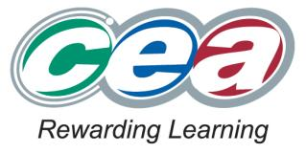
UCAS https://www.ucas.com
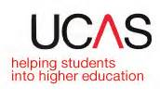
BBC Bitesize www.bbc.co.uk/schools/gcsebitesize
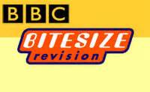

CEOP www.ceop.police.uk
Southern Education Authority Transition App http://movingforward.me/
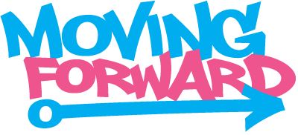

NI Careers Direct www.nidirect.gov.uk › Education, learning and skills

